**Hampton Roads Chess Association**

**Fiscal Year 2018 (FY18) Financial Statement**

Prepared on 9/23/18 based on data as of 8/31/2018

**Dear Hampton Roads Chess Association Officers and Members:**

**Introduction:** I (Jacquelinda Bowman) assumed duties as the Hampton Roads Chess Association (HRCA) Bookkeeper in May 2018. I have been working closely with the HRCA President and club treasurers to streamline HRCA accounting procedures, create thorough documentation of income and expenses, and track receipts and disbursements of donations.

**Summary:** The HRCA accounts comprise of a checking account and PayPal account. Our TOTAL ASSETS are $10,300.71. The total NET CHANGE for FY 2018 is $2,081.19. Of the total assets, $1,840.43 is in temporarily restricted donations. HRCA does not currently have any debt, real estate, or investments. HRCA sponsors nine scholastic chess programs and one adult chess program in addition to several charitable funds.

**Hampton Roads Chess Association accounts and banking information**: The Hampton Roads Chess Association Fiscal Year (FY) starts on September 1st and ends the following August 31st. This report includes information for the HRCA checking account and PayPal account. As of 8/31/18, there were 4 checks totaling **$950.00** that had not been cleared. The balances below include these outstanding checks.

|  |  |  |  |
| --- | --- | --- | --- |
| **Account** | **FY Start (9/1/2017)** | **FY End (8/31/2018)** | **Net Change** |
| HRCA Checking | $4,031.08 | $4,473.05 | $441.97 |
| HRCA PayPal | $4,188.44 | $5,827.66 | $1,639.22 |
| **TOTALS** | **$8,219.52** | **$10,300.71** | **$2,081.19** |

**Membership Income:** We received $1,497.50 in HRCA Memberships Fees. The previous FY we collected $910.00.

**HRCA Website:** We paid $132.32 in web hosting fees for FY 2017-2018. We used GoDaddy web hosting services, which increased from $7.99/month to $9.99/month January 1, 2018. In July, we canceled GoDaddy and fully switched over to Microsoft’s program for non-profits, which includes free web hosting. We paid $40.34 in July for web domain fees for two years.

**Independent Contractor Fees:** HRCA utilizes Independent Contractors for coaching and bookkeeping services.

* **Coaches.** Coaches are paid from the collection of dues and training fees. Our coaches were paid a total of $11,332.50 in FY18. Included in this amount is $252.50 in coaching fees owed from FY17.
* **Background** **Checks.** We spent $484.00 to conduct background checks for coaches and volunteers in FY18 through Verified Volunteer.
* **USCF Coach Application Fees.**  USCFCoach Application fees were $675.00.
* **Bookkeeping**. The increased growth of HRCA programs required the need of bookkeeping services. Bookkeeping expenses for FY18 were $2,760.05.

**Tournaments and Events:** HRCA sponsored 8 tournaments and 1 fundraiser in FY18.

* **Tournament Entry Fees:** $6,560 was collected in entry fees after cash prizes were disbursed.
* **Facility Usage:** HRCA paid $659.50 for the use of Virginia Beach Public School facilities to host a tournament. An additional $625.00 was donated to Eastminster Presbyterian Church from the HRCA General Fund for use of their facilities for tournaments.
* **Awards and Prizes (non-cash):** HRCA spent $6,715.96 on awards and $1,513.37 for other prizes across its scholastic programs.

**Miscellaneous Items:**

* **Insurance.** We renewed our non-profit insurance policy for $415.00 in January 2018. This covers the period of 1/25/2018-1/25/2019.
* **USCF Affiliate Fee:** We paid $40 in January 2018 to USCF to maintain our status as a USCF Affiliate.
* **State Corporation Commission:** We paid $25 in July 2018 for our annual nonprofit filing fee.

**Donations and Gifts Received:**

* **General Fund:** HRCA received $1,140.00 in unrestricted donations and $107.71 in temporarily restricted donations (designated for PayPal Fees) to the General Fund**.**
* **Chess for Disabilities:** This is a new donation fund for FY18**.** HRCA received $1,156.61 in donations designated for Chess with Disabilities programs.
* **Joan H. Schlich Memorial Scholarship:** The Schlich Memorial Scholarship had an opening balance of $2,075. HRCA received $271.43 in donations designated for the Schlich Scholarship in FY18.

**Donations and Gifts Disbursed:**

* **General Fund:** $186.07 was used from the General Fund to purchase chess sets for veterans at White Sulphur Springs Retreat Center ($99.66) and to assist with the purchase of a voice clock for the Chess for Disabilities program ($77.41). Additionally, $107.71 designated for PayPal fees was applied to our $317.62 in PayPal expenses.
* **Chess for Disabilities:** A $1,000 stipend was given to a member of our Scholastic Program to attend the World Junior Chess Championship for the Disabled in New Jersey. A special voice clock was purchased for $234.02 for our Disabilities program. It is currently on loan to our scholastic player.
* **Joan H. Schlich Memorial Scholarship:** $486.00 was given during FY18 to members in financial need. $461 was disbursed to help player costs associated with attending Virginia State Championships and $25 was reallocated for ChessKid Gold Accounts for 5 students.

**Report Attachments:**

Attachment 1: Hampton Roads Chess Association Net Worth by Quarter for FY18  
Attachment 2: Hampton Roads Chess Association Donation Report for FY18

I affirm that this report is accurate to the best of my knowledge.



Jacquelinda Bowman  
Hampton Roads Chess Association Bookkeeper

**Attachment 1: Hampton Roads Chess Association Net Worth by Quarter for FY18**

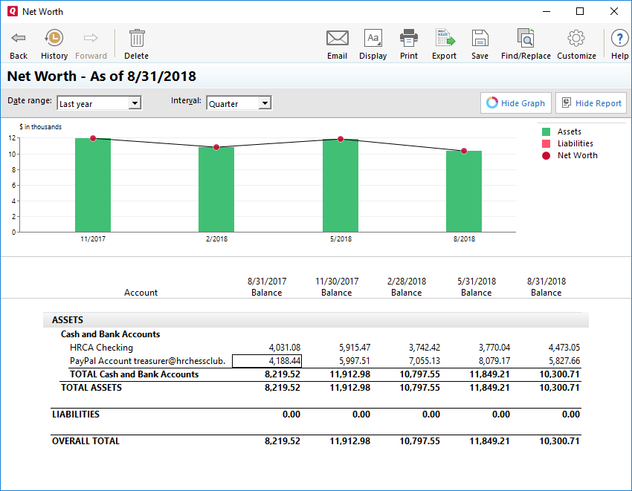

**Attachment 2: Hampton Roads Chess Association Donation Report for FY18**

|  |  |  |  |  |
| --- | --- | --- | --- | --- |
| **Hampton Roads Chess Association** | | | | |
| **FY 2017-2018 Donations & Disbursements** | | | | |
|  |  |  |  |  |
| **CONTRIBUTIONS** |  |  |  |  |
| **Fund** | **Opening Balance** | **Without Restrictions** | **With Temporary Restrictions** | **Balance:** |
| General Fund (UR) |  | $1,140.00 | $114.04 | **$1,254.04** |
| Chess for Disabilities (TR) | $0.00 | $0.00 | $1,156.61 | **$1,156.61** |
| Schlich Memorial Scholarship (TR) | $2,075.00 | $0.00 | $271.43 | **$2,346.43** |
| Member Donations to USCF  (TR) | $0.00 | $0.00 | $10.00 | **$10.00** |
| Member Donations to EPC (TR) | $0.00 | $0.00 | $470.00 | **$470.00** |
| **TOTALS:** | **$2,075.00** | **$1,140.00** | **$2,022.08** | **$5,237.08** |
|  |  |  |  |  |
| **DISBURSEMENTS** |  |  |  |  |
| **Fund** | **Without Restrictions** | **With Temporary Restrictions** | **Disbursement Totals:** | **Closing Balance:** |
| General Fund (UR) | $177.07 | $114.04 | **$291.11** | **$962.93** |
| Chess for Disabilities (TR) |  | $1,156.61 | **$1,156.61** | **$0.00** |
| Schlich Memorial Scholarship (TR) |  | $486.00 | **$486.00** | **$1,860.43** |
| Member Donations to USCF  (TR) |  | $10.00 | **$10.00** | **$0.00** |
| Member Donations to EPC (TR) |  | $470.00 | **$470.00** | **$0.00** |
| **TOTALS:** | **$177.07** | **$1,264.65** | **$1,441.72** | **$2,823.36** |
|  |  |  |  |  |
| UR- Unrestricted |  |  |  |  |
| TR- Temporarily Restricted |  |  |  |  |